Like and Unlike Fractions
Like fractions are fractions with same denominator. For eg ½, 15/2, 19/2 and so on.
Unlike fractions are fractions with different denominators. For e.g. 16/5, 7/8, ½, 2/5, 2/10.
It is important to note that like and unlike fractions are decided only on the basis of denominator. The value of numerator does not matter.
Equivalent Fractions
Equivalent fractions are fractions which represent the same number.
For e.g. Tipu divides the pizza into 2 equal halves and eats one half of it. Bhola divides the same pizza into 4 equal halves and eats two parts of it.
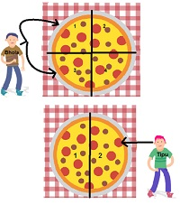
Share of Pizza eaten by Bhola = 2 parts out of 4 = 2/4. This can be further reduced to get :
2/4 = ½ = 0.5
Share of Pizza eaten by Tipu = 1 part of out of 2 = ½.
½ = 0.5.

Thus, although the fractions are 2/4 and 1/2 but they represent the same numbers. Hence they are equivalent fractions.
In order to make equivalent number, we have to multiply both the numerator and the denominator by the same number. For eg we get the following fractions when we keep on dividing both the numerator and the denominator by the number 2.
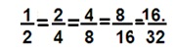
These fractions are equivalent since all of them can be reduced to the simplest fraction - ½.
Equivalent fraction can also be made by dividing both the numerator and the denominator by the same number.
It is important to note that the number by which we divide has to be such that the number divides both the numerator and the denominator perfectly.
Therefore, we can first find the HCF of the numerator and the denominator then divide them by the HCF.
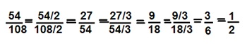
These fractions are equivalent since all of them can be reduced to the simplest fraction- ½.

